Assignment 16

Swaraj Wattamwar

150096724157

Jensen Huang

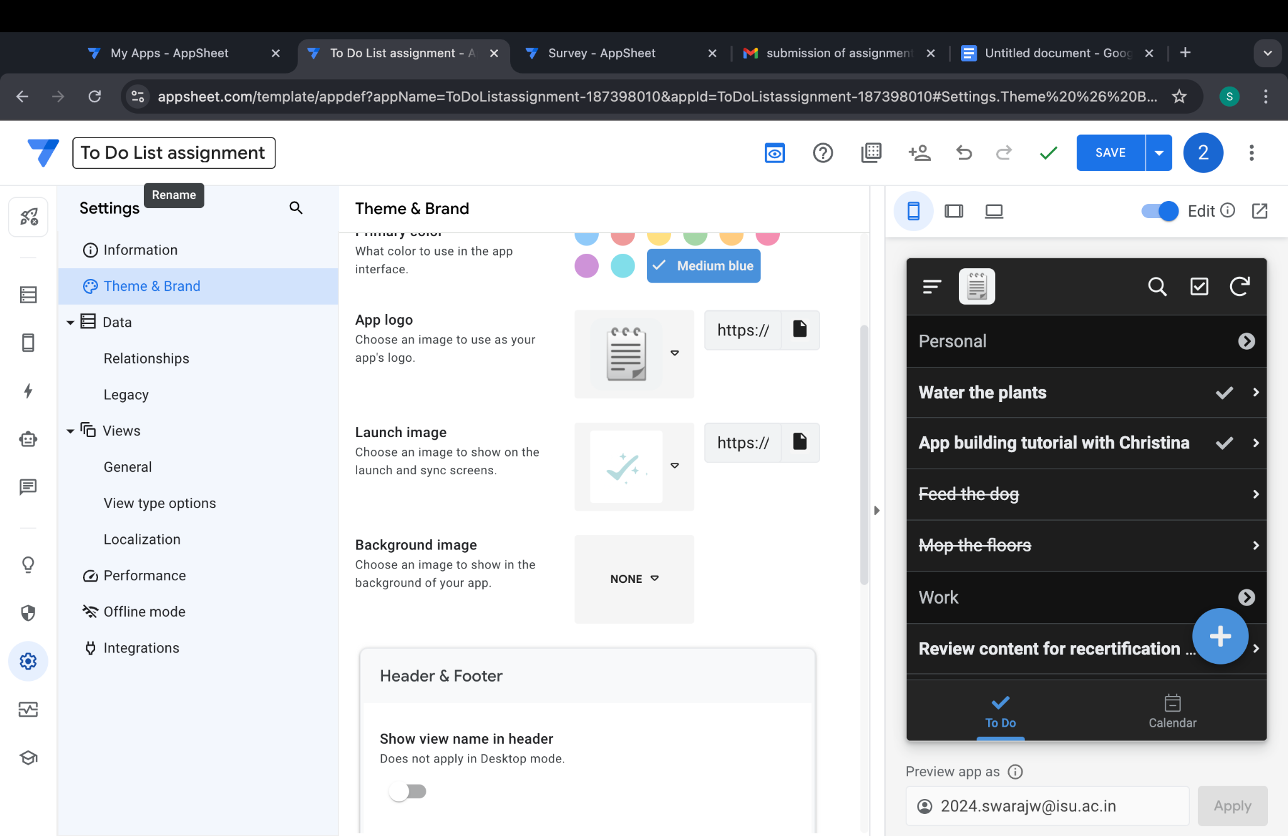

appSheet To_do_list

Survey app 